EX:05- Create a simple cloud software application for Library book reservation
system for SIMATS library using any Cloud Service Provider to demonstrate SaaS.
Aim
To Create a simple cloud software application for Library book reservation system for SIMATS library using any Cloud Service Provider to demonstrate SaaS.
Procedure
- Login to Cloud Platform – Sign in to a cloud service provider (Zoho Creator / AWS / Google Cloud / Azure).
- Create New Application – Start a new app, either with a blank project or by selecting a template.
- Design Forms & Modules – Add forms for student details, book details, reservation requests, and return info. Create reports to display available books, issued books, and reservation status.
- Set Workflows & Logic – Automate processes like reservation confirmation, due-date reminders, late-return alerts, and availability checks.
- Deploy the Application – Publish the library app on the cloud platform so it runs online.
- Provide SaaS Access – Share the application link with SIMATS students and staff so they can reserve/track books anytime as a SaaS service.
Output
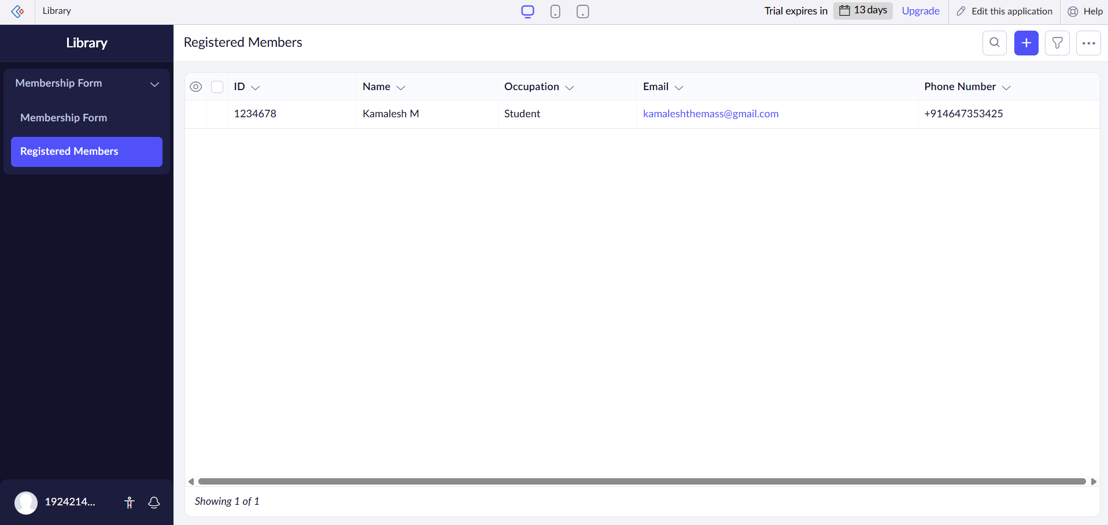
Result
Thus, to Create a simple cloud software application for Library book reservation system for SIMATS library using any Cloud Service Provider to demonstrate SaaS was created successfully.

